

AP® Physics C
1995 Free response Questions

The materials included in these files are intended for use by AP teachers for course and exam preparation in the classroom; permission for any other use must be sought from the Advanced Placement Program®. Teachers may reproduce them, in whole or in part, in limited quantities, for face-to-face teaching purposes but may not mass distribute the materials, electronically or otherwise. These materials and any copies made of them may not be resold, and the copyright notices must be retained as they appear here. This permission does not apply to any third-party copyrights contained herein.

These materials were produced by Educational Testing Service® (ETS®), which develops and administers the examinations of the Advanced Placement
Program for the College Board. The College Board and Educational Testing Service (ETS) are dedicated to the principle of equal opportunity, and their
programs, services, and employment policies are guided by that principle.

The College Board is a national nonprofit membership association dedicated to preparing, inspiring, and connecting students to college and opportunity.
Founded in 1900, the association is composed of more than 4,200 schools, colleges, universities, and other educational organizations. Each year, the
College Board serves over three million students and their parents, 22,000 high schools, and 3,500 colleges, through major programs and services in
college admission, guidance, assessment, financial aid, enrollment, and teaching and learning. Among its best-known programs are the SAT®, the
PSAT/NMSQT®, and the Advanced Placement Program® (AP®). The College Board is committed to the principles of equity and
excellence, and that commitment is embodied in all of its programs, services, activities, and concerns.

APIEL is a trademark owned by the College Entrance Examination Board. PSAT/NMSQT is a registered trademark jointly owned by the College Entrance Examination Board and the National Merit Scholarship Corporation. Educational Testing Service and ETS are registered trademarks of Educational Testing Service.
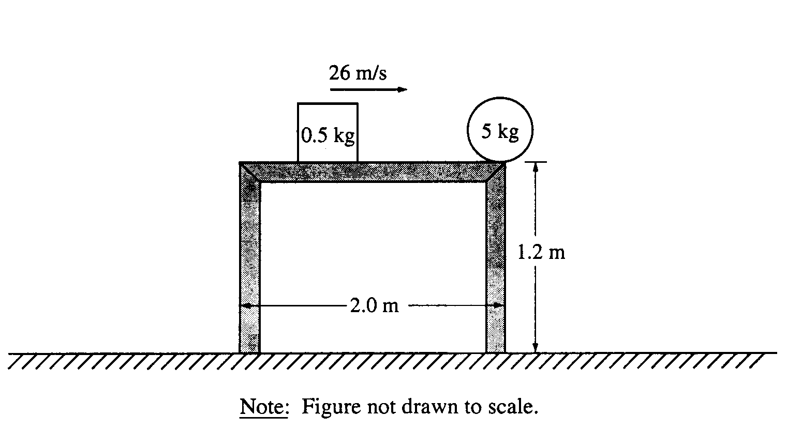
1995M1. A 5-kilogram ball initially rests at the edge of a 2-meter-long, 1.2-meter-high frictionless table, as shown above. A hard plastic cube of mass 0.5 kilogram slides across the table at a speed of 26 meters per second and strikes the ball, causing the ball to leave the table in the direction in which the cube was moving. The figure below shows a graph of the force exerted on the ball by the cube as a function of time.
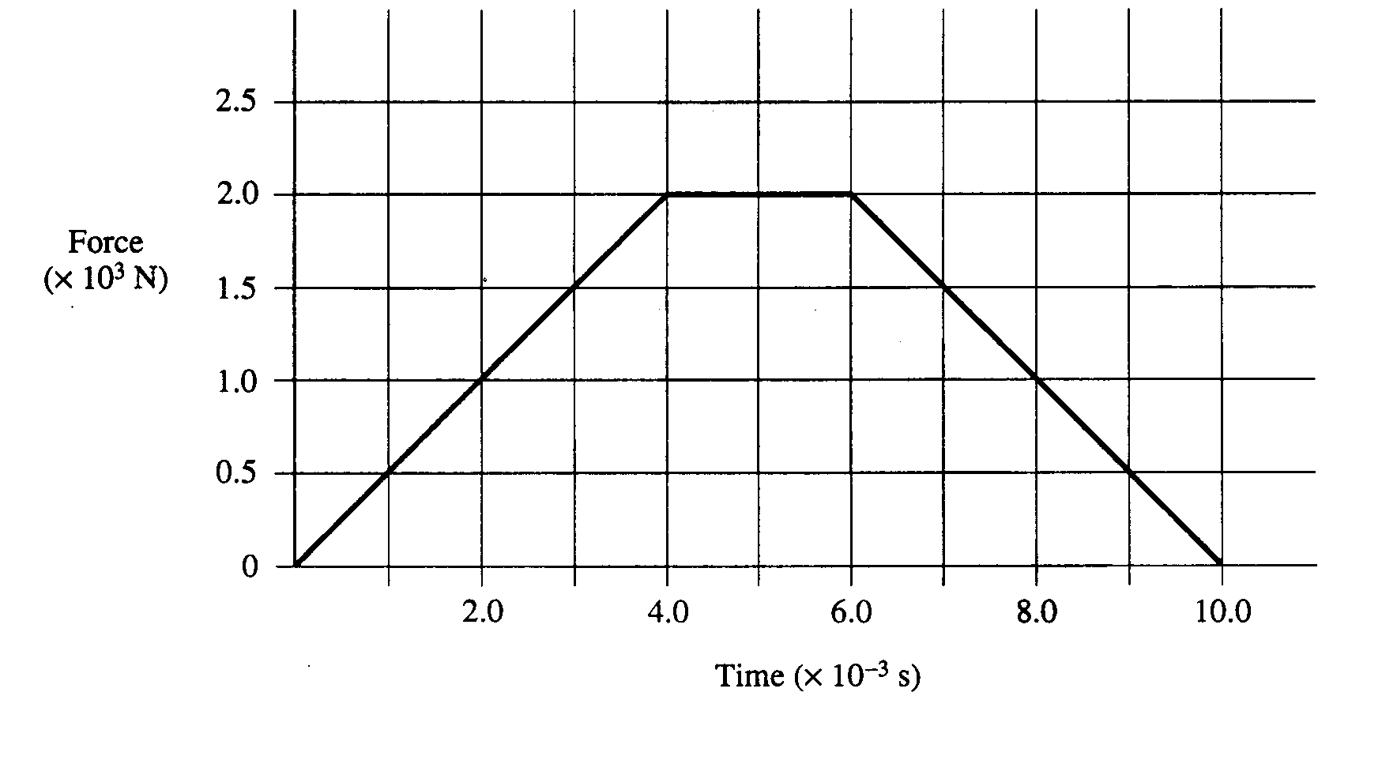
a. Determine the total impulse given to the ball.
b. Determine the horizontal velocity of the ball immediately after the collision.
c. Determine the following for the cube immediately after the collision.
i. Its speed
ii. Its direction of travel (right or left), if moving
d. Determine the kinetic energy dissipated in the collision.
e. Determine the distance between the two points of impact of the objects with the floor.

1995M2. A particle of mass m moves in a conservative force field described by the potential energy function U(r) = a(r/b + b/r), where a and b are positive constants and r is the distance from the origin. The graph of U(r) has the following shape.
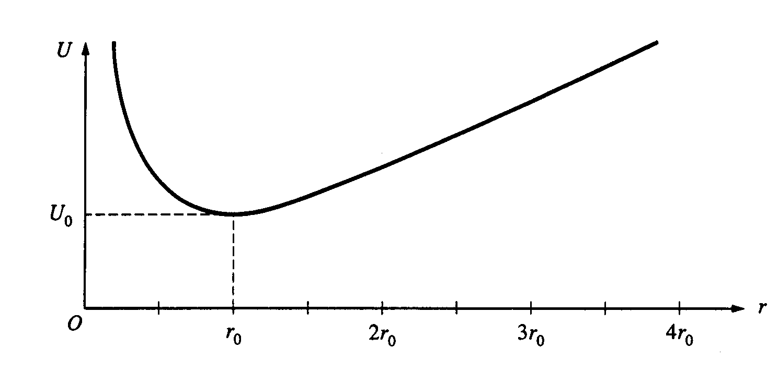
a. In terms of the constants a and b, determine the following.
i. The position r_{o} at which the potential energy is a minimum
ii. The minimum potential energy U_{o}
b. Sketch the net force on the particle as a function of r on the graph below, considering a force directed away from the origin to be positive, and a force directed toward the origin to be negative.
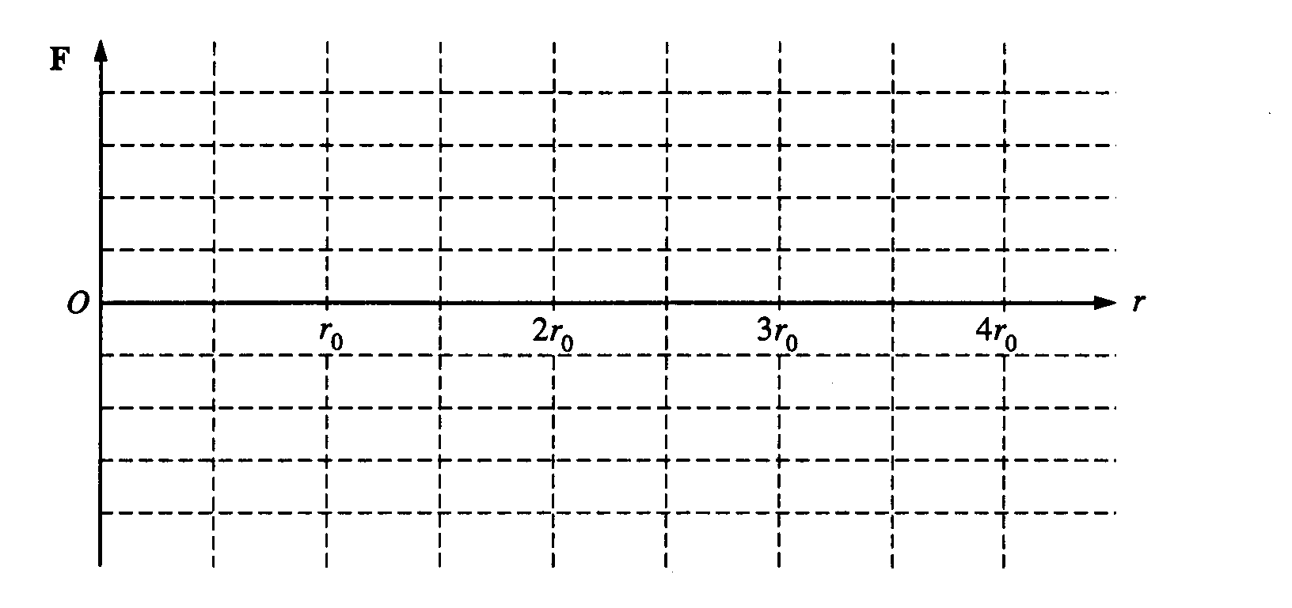
The particle is released from rest at r = r_{o}/2
c. In terms of U_{o} and m, determine the speed of the particle when it is at r = r_{o} .
d. Write the equation or equations that could be used to determine where, if ever, the particle will again come to rest. It is not necessary to solve for this position.
e. Briefly and qualitatively describe the motion of the particle over a long period of time.

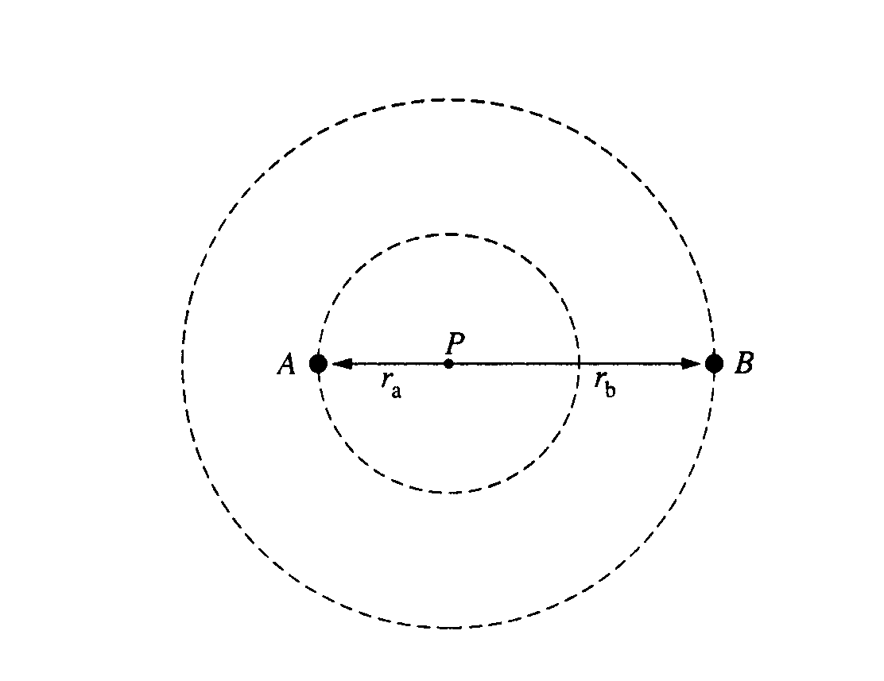
1995M3. Two stars, A and B. are in circular orbits of radii r_{a} and r_{b}, respectively, about their common center of mass at point P, as shown above. Each star has the same period of revolution T.
Determine expressions for the following three quantities in terms of r_{a}, r_{b}, T, and fundamental constants.
a. The centripetal acceleration of star A
b. The mass M_{b} of star B
c. The mass M_{a} of star A

Determine expressions for the following two quantities in terms of M_{a}, M_{b}, r_{a}, r_{b}, T, and fundamental constants.
d. The moment of inertia of the two-star system about its center of mass.
e. The angular momentum of the system about the center of mass.
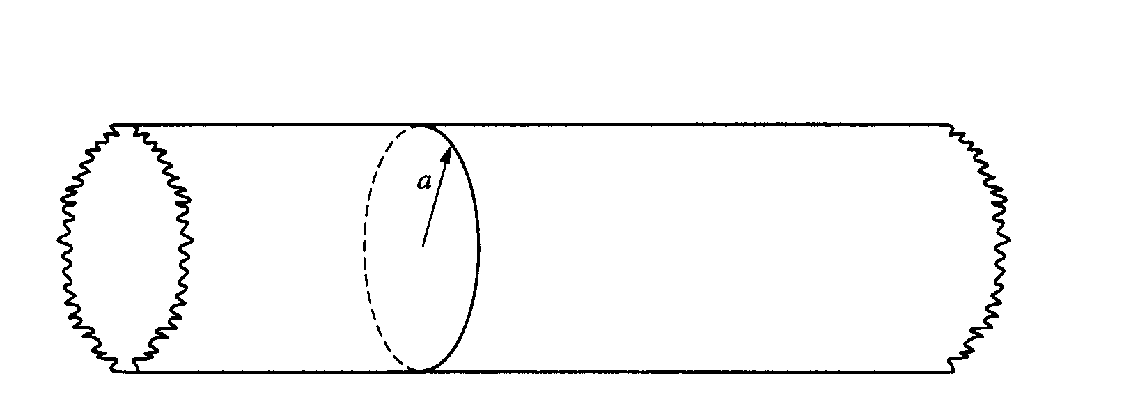
1995E1. A very long nonconducting rod of radius a has positive charge distributed throughout its volume. The charge distribution is cylindrically symmetric, and the total charge per unit length of the rod is λ .

a. Use Gauss's law to derive an expression for the magnitude of the electric field E outside the rod.
b. The diagrams below represent cross sections of the rod. On these diagrams, sketch the following.
i. Several equipotential lines in the region r > a
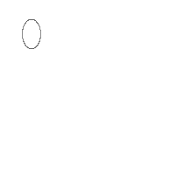
ii. Several electric field lines in the region r > a
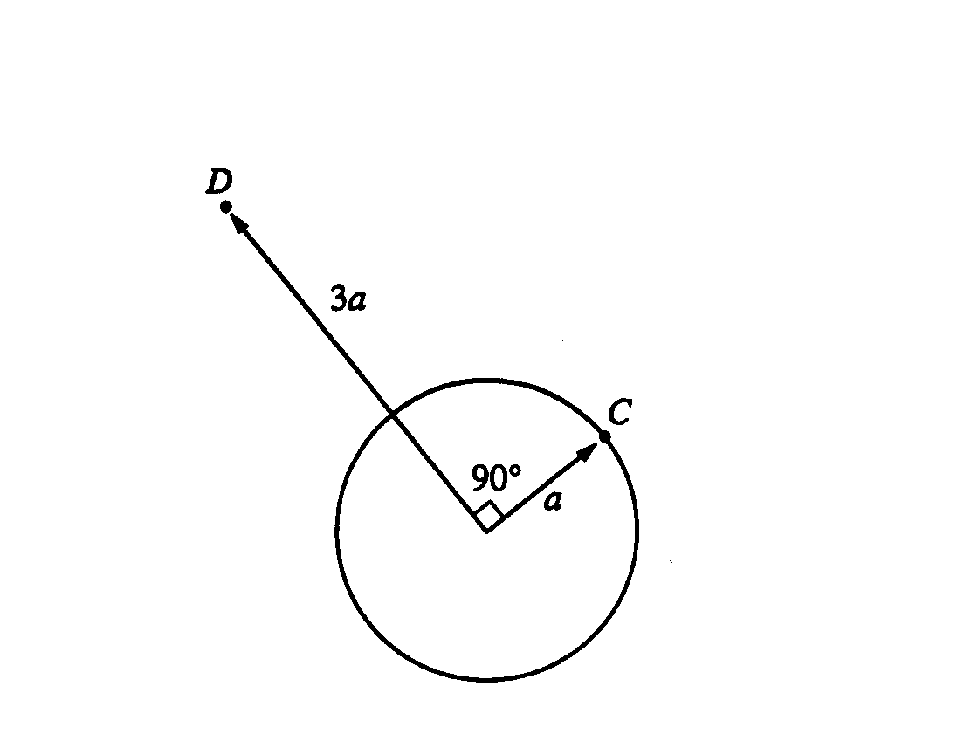

c. In the diagram above, point C is a distance a from the center of the rod (i.e., on the rod's surface), and point D is a distance 3a from the center on a radius that is 90° from point C. Determine the following.
i. The potential difference Vc - VD between points C and D
ii. The work required by an external agent to move a charge + Q from rest at point D to rest at point C
Inside the rod (r < a), the charge density ρ is a function of radial distance r from the axis of the rod
and is given by ρ=ρ_{o}(r/a)^{½}, where ρ_{o} is a constant.
d. Determine the magnitude of the electric field E as a function of r for r < a. Express your answer in terms of ρ_{o}, a, and fundamental constants.
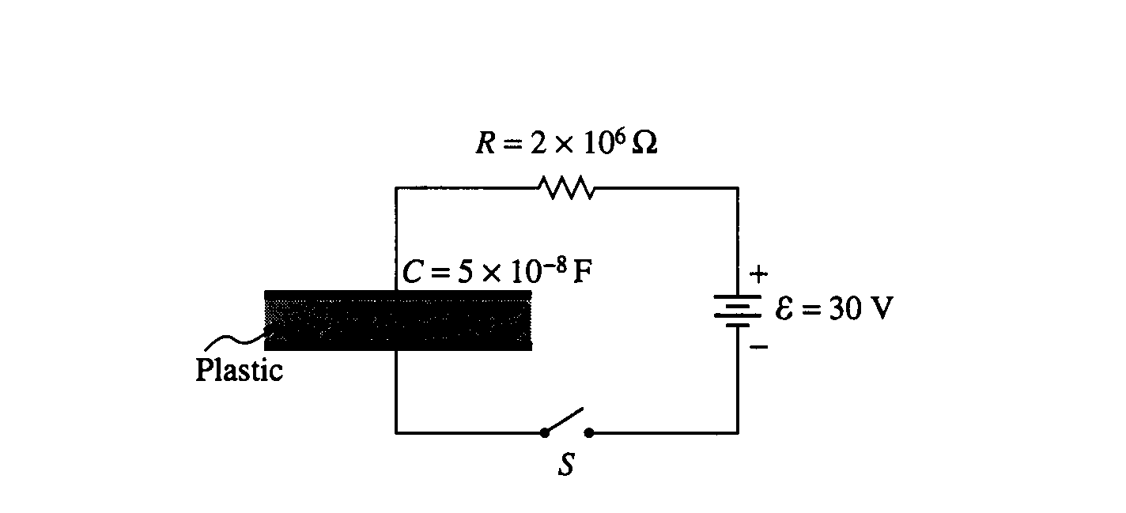
1995E2. A parallel-plate capacitor is made from two sheets of metal, each with an area of 1.0 square meter, separated by a sheet of plastic 1.0 millimeter (10⁻³ m) thick, as shown above. The capacitance is measured to be 0.05 microfarad (5 x 10⁻⁸ F) .
a. What is the dielectric constant of the plastic?
b. The uncharged capacitor is connected in series with a resistor R = 2 x 10⁶ ohms, a 30-volt battery, and an open switch S, as shown above. The switch is then closed.
i. What is the initial charging current when the switch S is closed?
ii. What is the time constant for this circuit?
iii. Determine the magnitude and sign of the final charge on the bottom plate of the fully
charged capacitor.
iv. How much electrical energy is stored in the fully charged capacitor?

After the capacitor is fully charged, it is carefully disconnected, leaving the charged capacitor isolated in space. The plastic sheet is then removed from between the metal plates. The metal plates retain their original separation of 1.0 millimeter.
c. What is the new voltage across the plates?
d. If there is now more energy stored in the capacitor, where did it come from? If there is now less energy, what happened to it?

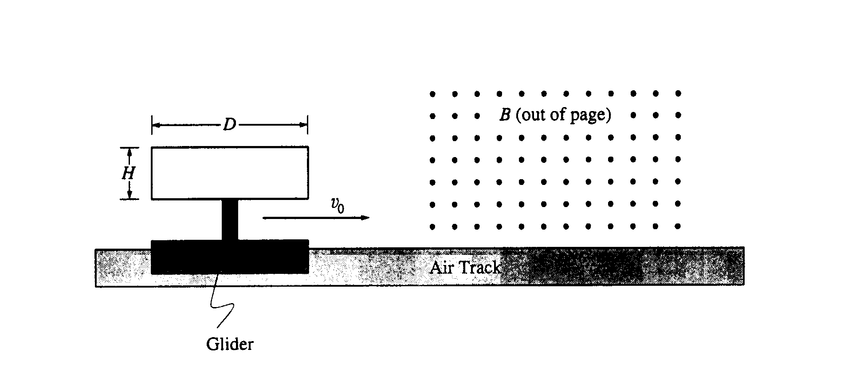
1995E3. The long, narrow rectangular loop of wire shown above has vertical height H, length D, and resistance R. The loop is mounted on an insulated stand attached to a glider, which moves on a frictionless horizontal air track with an initial speed of v_{o} to the right. The loop and glider have a combined mass m. The loop enters a long, narrow region of uniform magnetic field B, directed out of the page toward the reader. Express your answers to the parts below in terms of B, D, H, R, m, and v_{o}.
a. What is the magnitude of the initial induced emf in the loop as the front end of the loop begins to enter the region containing the field?
b. What is the magnitude of the initial induced current in the loop?
c. State whether the initial induced current in the loop is clockwise or counterclockwise around the loop.
d. Derive an expression for the velocity of the glider as a function of time t for the interval after the front edge of the loop has entered the magnetic field but before the rear edge has entered the field.
e. Using the axes below, sketch qualitatively a graph of speed v versus time t for the glider. The front end of the loop enters the field at t = 0. At t₁ the back end has entered and the loop is completely inside the field. At t₂ the loop begins to come out of the field. At t₃ it is completely out of the field. Continue the graph until t₄, a short time after the loop is completely out of the field. These times may not be shown to scale on the t-axis below.
